**CSLR62**

**App Development Lab End Sem**

Name: Haemanth V

Roll Number: 106119043

Class: CSE-A

**Question 5. Online Bus Ticket Booking App**

Features implemented:

* Login and registration
* View list of buses
* Graphical map of seats in buses
* Sleeper and seater coaches in Buses
* Restrict App Screenshots(feature was disabled to take demo screenshots alone)
* Book tickets
* Cancel tickets with refund option(implemented after exam)
* Online payment and wallet
* View booking history(Press Floating Action Button in Homescreen)

Source Code: <https://drive.google.com/drive/folders/14e-DxX3sf0jyVn9s1bIOXR-LmuEXUdvs?usp=sharing>

App Screenshots:

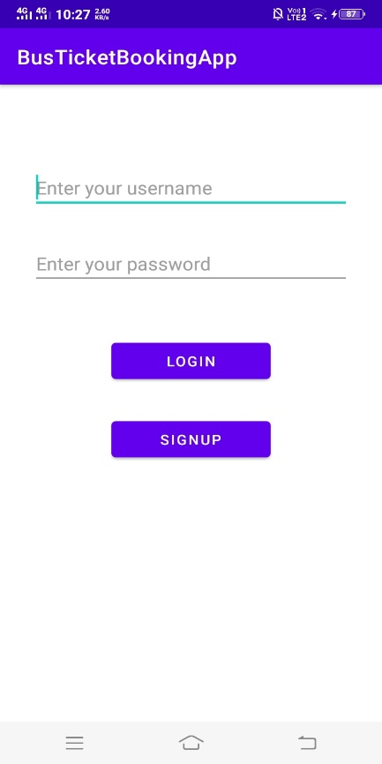 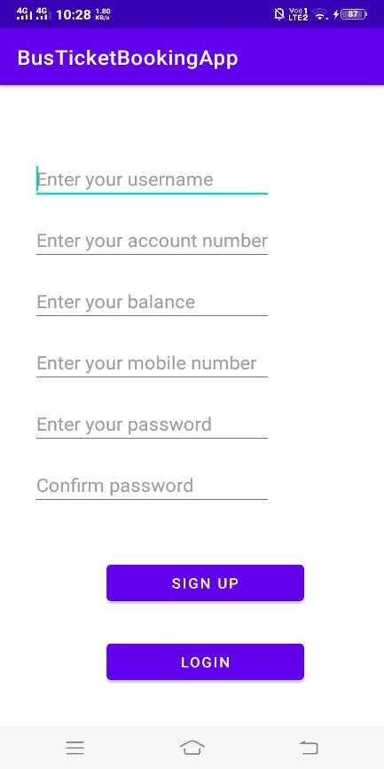

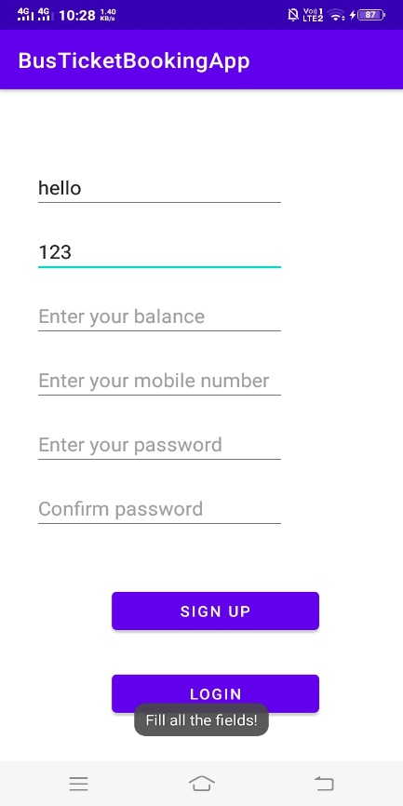 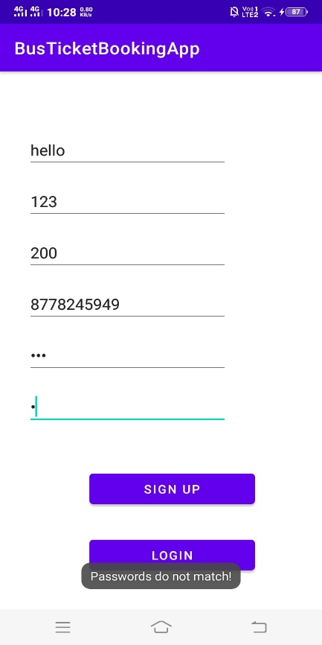

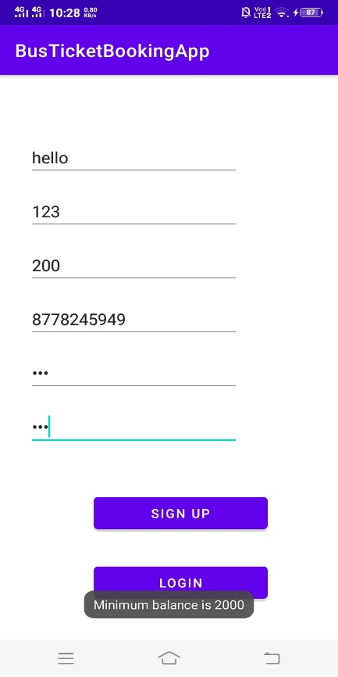 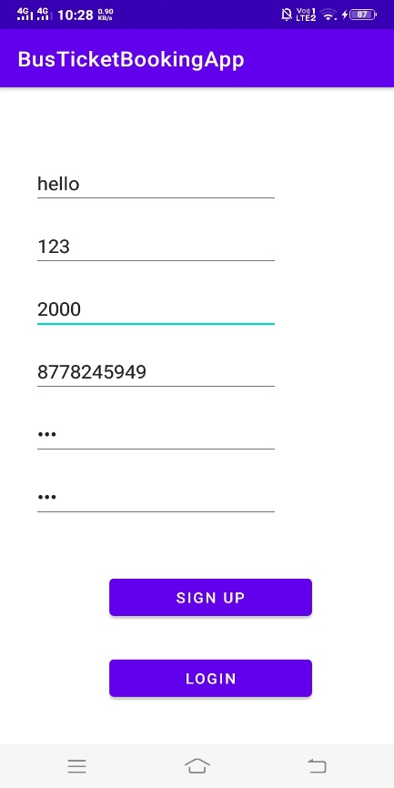

User Dashboard - After Successful SignUp(user is loggedin directly) or login

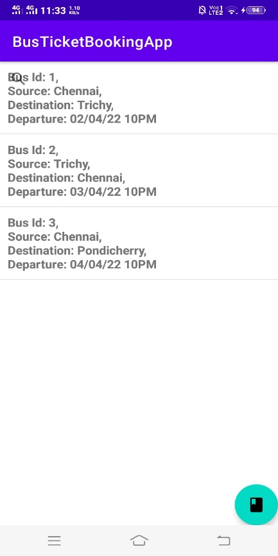

Pressing the floating action button here opens the booking history of the user

Seat Map of Bus with seater and sleeper coach

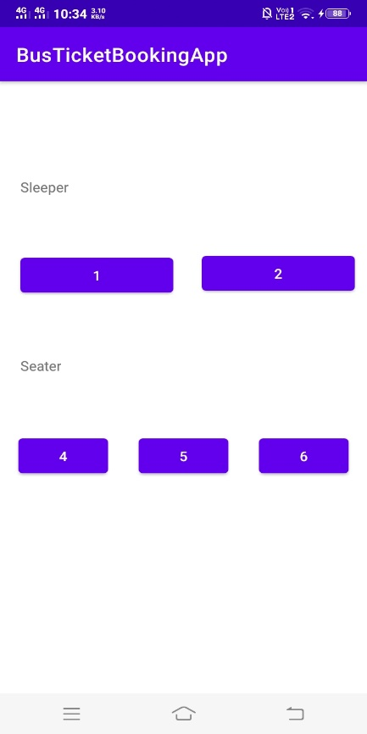

Ticket booked successfully(shows booking history with latest booking)

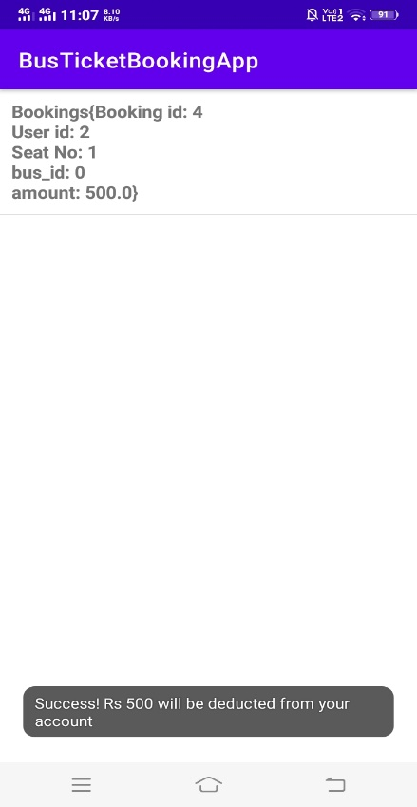

Payment deduction from user’s online wallet(reflected in database)

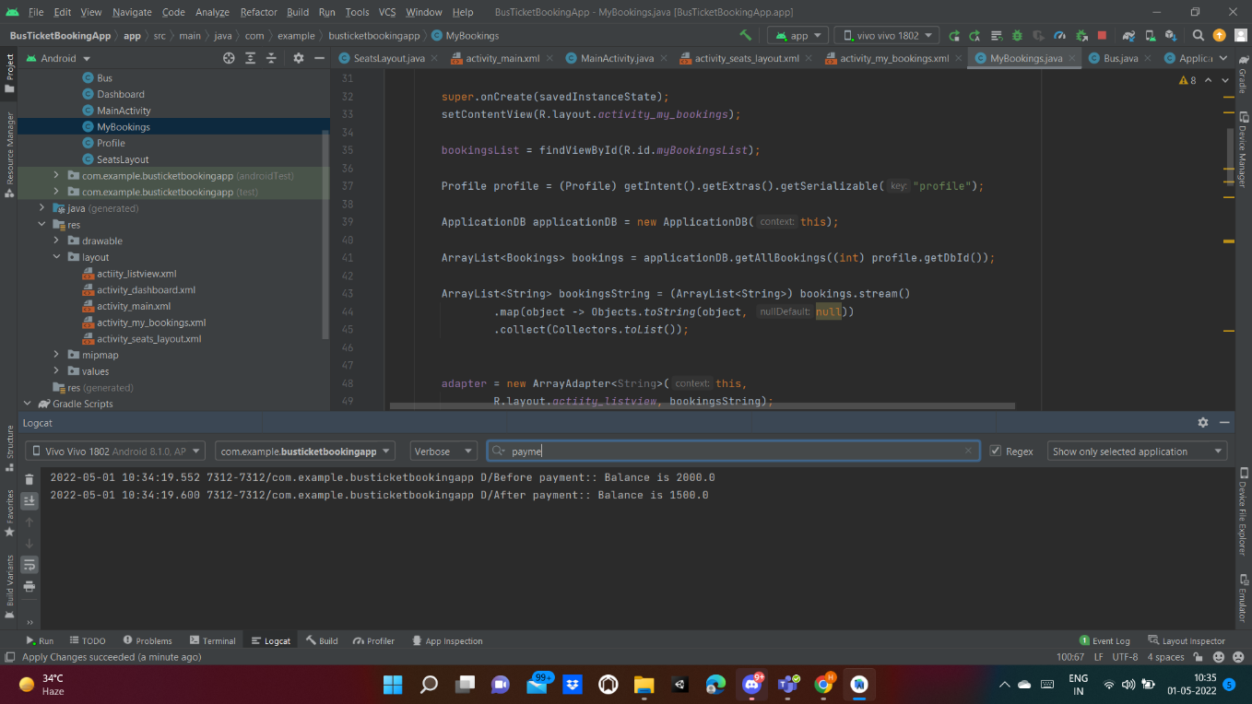

Book another ticket

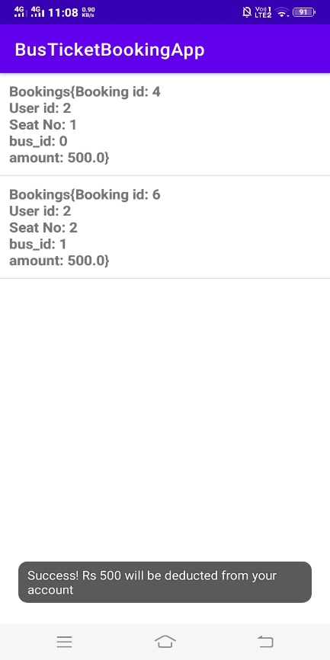

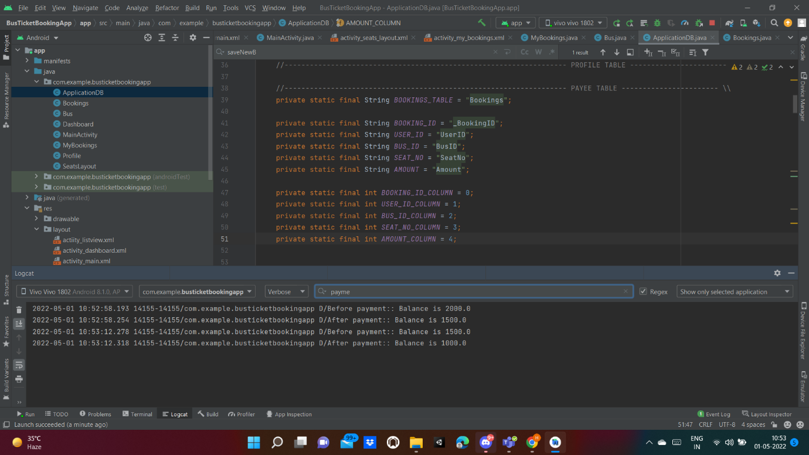

Cancelling tickets:

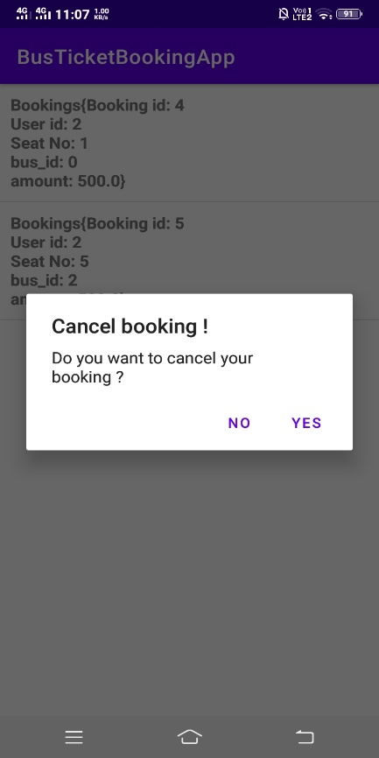 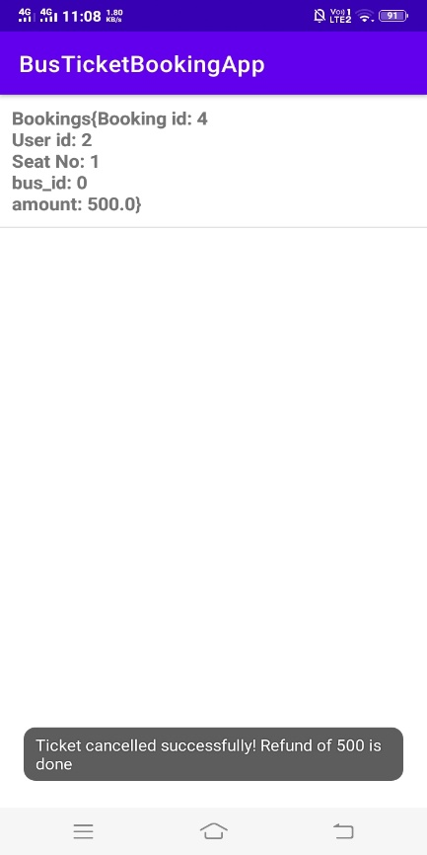

Amount refund for cancelled tickets

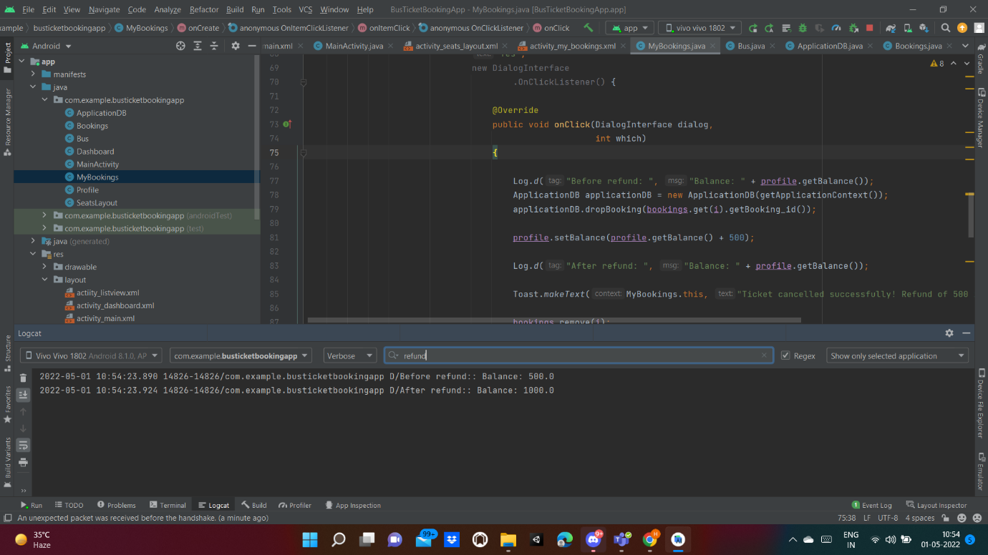

Trying to Book a seat that is already booked:

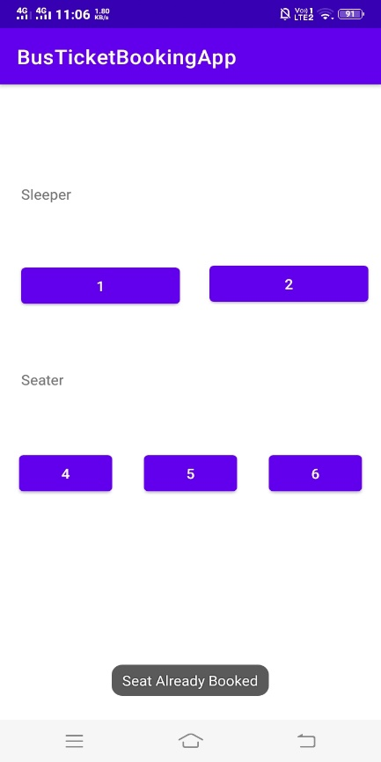

Trying to book a seat with insufficient balance

